

**Submitted by:**

Burhan Baig

**Referred to:**

Sir. Muhammad Affan

**Roll no:**

460945

**Fundamentals of Programming**

Assignment no. 2

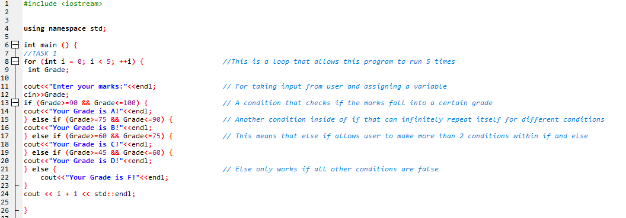TASK 1

OUTPUT

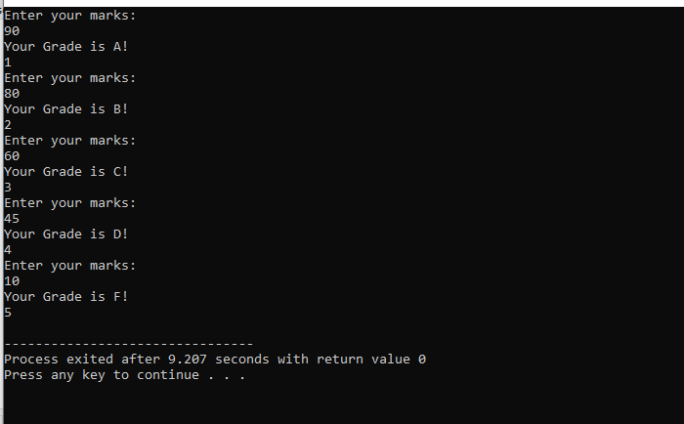

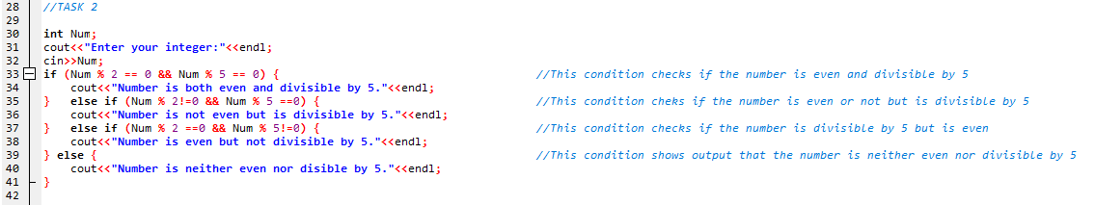TASK 2

OUTPUT

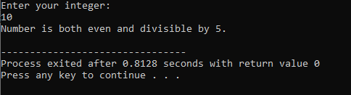

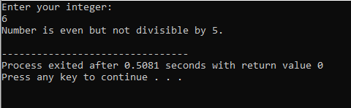

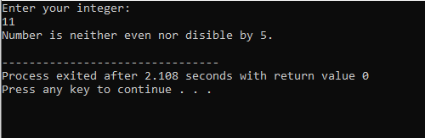

TASK 3

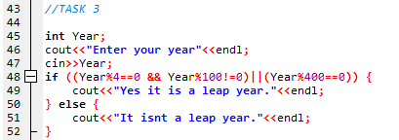

OUTPUT

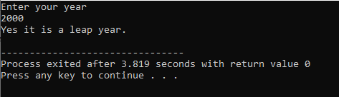

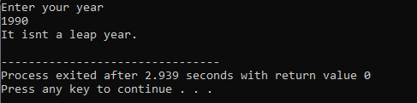

TASK 4

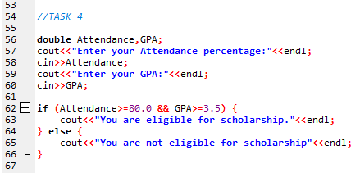

OUPUT

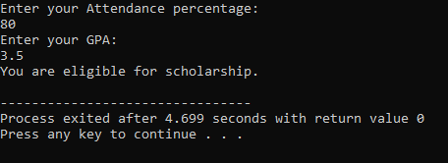

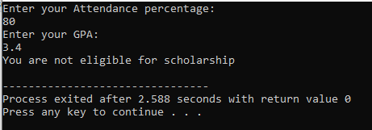

TASK 5

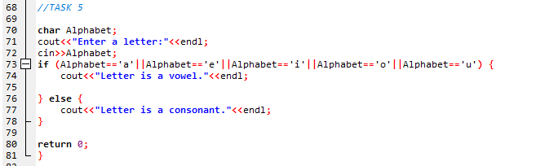

OUTPUT

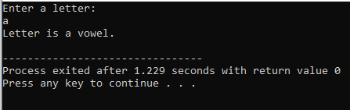

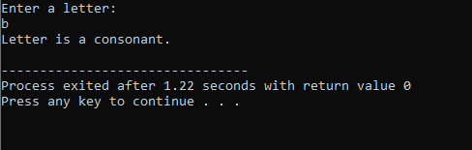

THE END